Woven Together: A Dialogue on Racism
Speakers’ Resource Recommendations

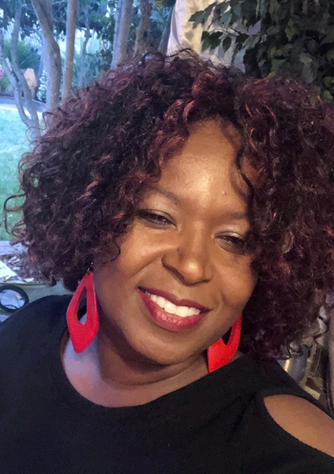

Scriptures Referenced in Episode:

Luke 12:48b- "When someone has been given much, much will be required in return; and when someone has been entrusted with much, even more will be required.”

Jeremiah 33:6- “Nevertheless, I will bring health and healing to it; I will heal my people and will let them enjoy abundant peace and security.”

Isaiah 40:29- “He gives strength to the weary and increases the power of the weak.”

Galatians 6:9- “Let us not become weary in doing good, for at the proper time we will reap a harvest if we do not give up.”

1 Samuel 16:7b- “The LORD does not look at the things people look at. People look at the outward appearance, but the LORD looks at the heart."

Psalm 62:5-8- “Yes, my soul, find rest in God; my hope comes from him. Truly he is my rock and my salvation; he is my fortress, I will not be shaken. My salvation and my honor depend on God; he is my mighty rock, my refuge. Trust in him at all times, you people; pour out your hearts to him, for God is our refuge.”

Romans 12:14-16 "Bless those who persecute you; bless and do not curse. Rejoice with those who rejoice; mourn with those who mourn. Live in harmony with one another....”

Psalm 34:18 “The Lord is close to the brokenhearted and saves those who are crushed in spirit.”

DeShonda’s Recommendations:

- Netflix’s 13th by Ava DuVernay- Many cite The New Jim Crow (book by Michelle Alexander) as what woke them up to the extreme injustice in our criminal justice system and arguably 13th would be the documentary version of that, exposing how deep-rooted institutionalized racism is.

- How to be Anti-Racist:
- https://parade.com/1045096/jessicasager/how-to-be-anti-racist/

- Racism has a cost for everyone:
- https://www.ted.com/talks/heather_c_mcghee_racism_has_a_cost_for_everyone?utm_campaign=tedspread&utm_medium=referral&utm_source=tedcomshare

- Don’t be a savior, be an Ally:
- https://www.ted.com/talks/rayna_gordon_don_t_be_a_savior_be_an_ally?utm_campaign=tedspread&utm_medium=referral&utm_source=tedcomshare

- Resources Understanding Systemic Racism in America:
- https://www.smithsonianmag.com/history/158-resources-understanding-systemic-racism-america-180975029/

Shantae’s Recommendations:

- White privilege explained
- https://www.youtube.com/watch?v=XlRxqC0Sze4

- Questions answered from a black man
- https://www.youtube.com/watch?v=h8jUA7JBkF4

- Systemic racism and black lives matter explained
- https://www.youtube.com/watch?v=34qNFIH3vCE

Morgan’s Recommendations:

- Netflix Documentaries: 13th, Let Them Fall, LA 92, and she plans on watching the rest in their Black Lives Matter Collection

Books:
  - Generous Justice - Tim Keller
  - The Color of Compromise - Jemar Tisby
  - The New Jim Crow: Mass Incarceration in the Age of Colorblindness - Michelle Alexander
Websites:
- Brownicity: https://brownicity.com/
- White Fragility: https://robindiangelo.com/
- The urgency of intersectionality: https://www.ted.com/talks/kimberle_crenshaw_the_urgency_of_intersectionality
- Bryan Stevenson: We need to talk about an injustice https://www.ted.com/talks/bryan_stevenson_we_need_to_talk_about_an_injustice
- Children Will Light Up The World If We Let Them https://youtu.be/q0YDt64IWFU
- bit.ly/ANTIRACISMRESOURCES

